Jeanette Pranin

HW#3

1. One of the first problems we encountered was taking pictures with the camera. Some pictures had a black/noisy streak at the top. We solved this problem by taking multiple pictures of the same scene and picking a flash/no flash pair that did not have this error.

* Example of noisy streak

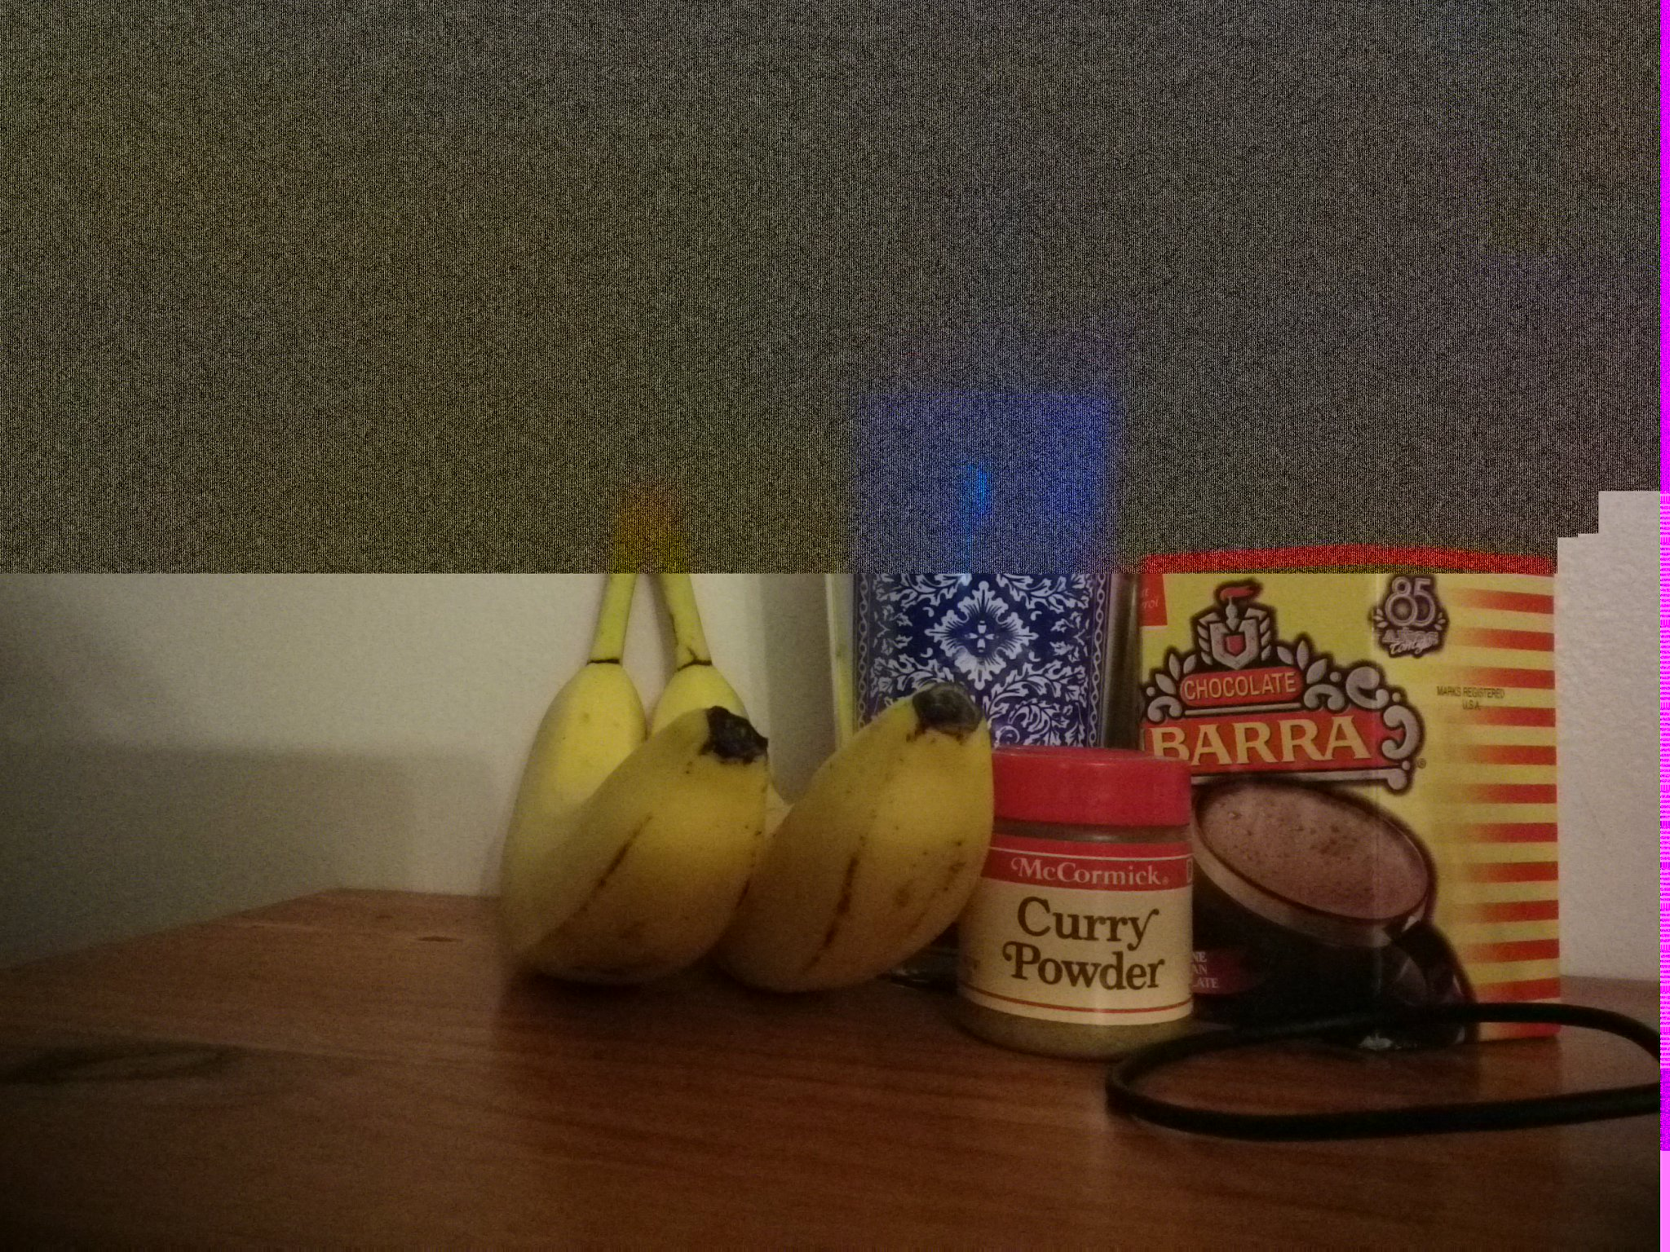

1. Here is our actual flash/no flash pair

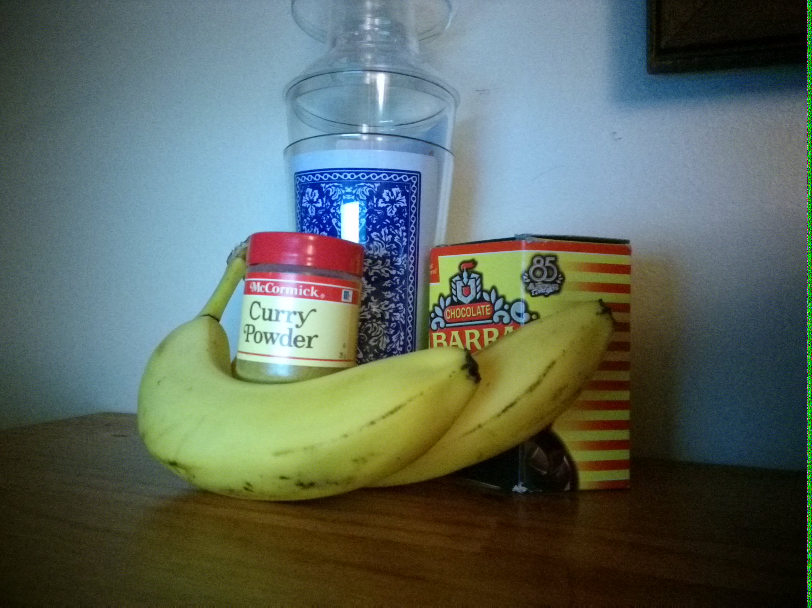

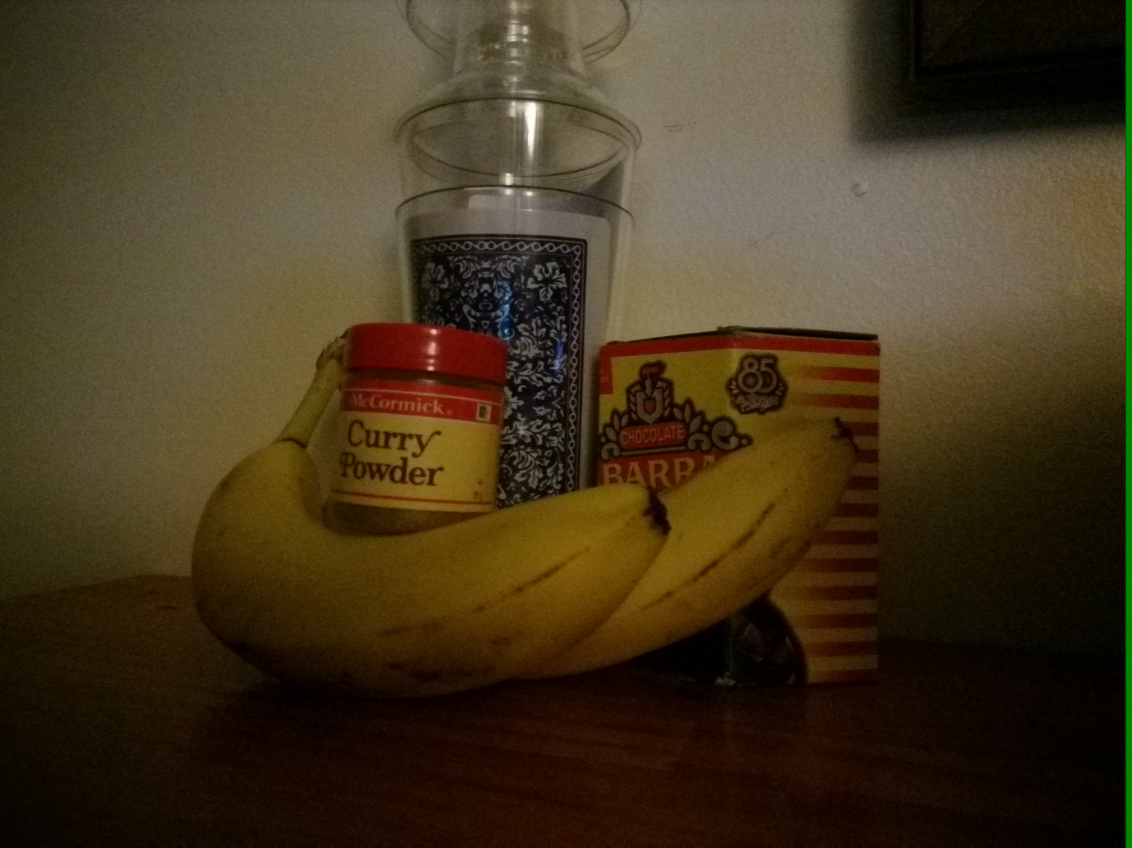

1. Another problem we encountered was that the code ran very slowly. Because of this, seeing the different result when changing the values for r [0.05, 0.25] and s [1, 64] was tedious. However, changing the dimensions to 1024x768 significantly cut down the run time.
2. One more problem was the lower the value of r, the longer the code took to execute. When testing r = 0.05, my computer crashed. Because the convolution gets bigger as the value gets smaller, the problem was most likely not having enough RAM to execute the function. However, when testing r = 0.25, it executed each line of code within 30 seconds. Therefore, we could only test values of r 0.15.
3. r 0.25 and s 64

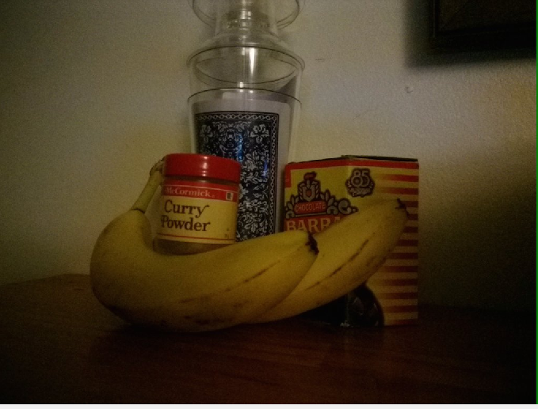

1. r 0.25 and s 50

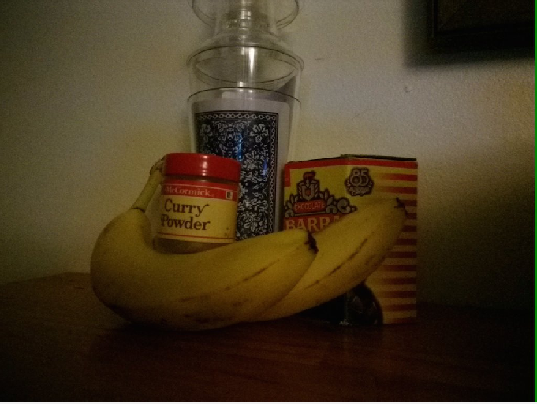

1. r 0.25 and s 10

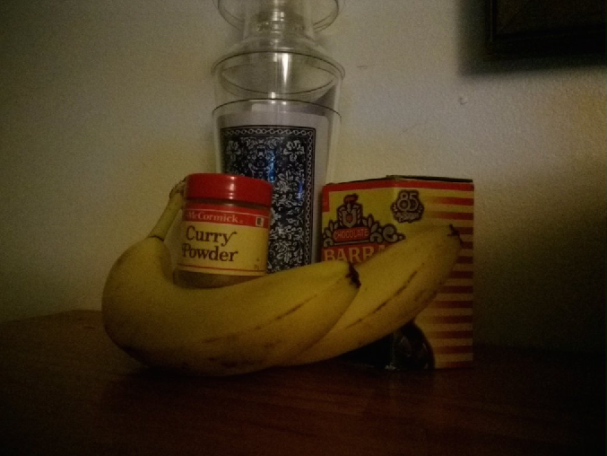

1. r 0.25 and s 1

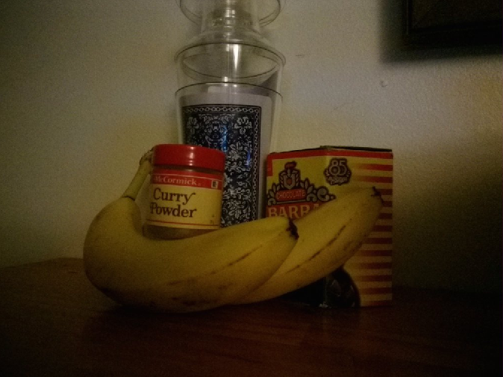

1. r 0.25 and s 30

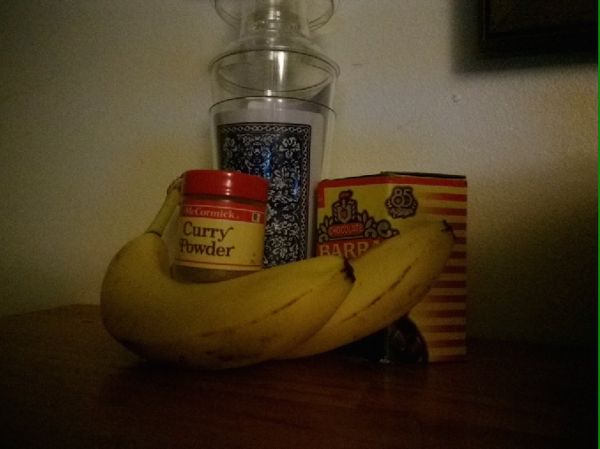

1. r 0.20 and s 30

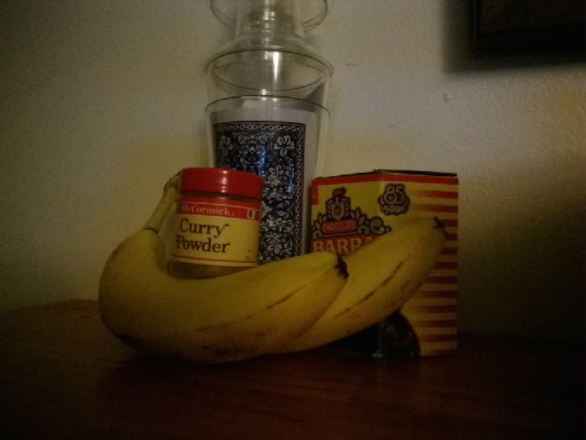

1. r 0.15 and s 30

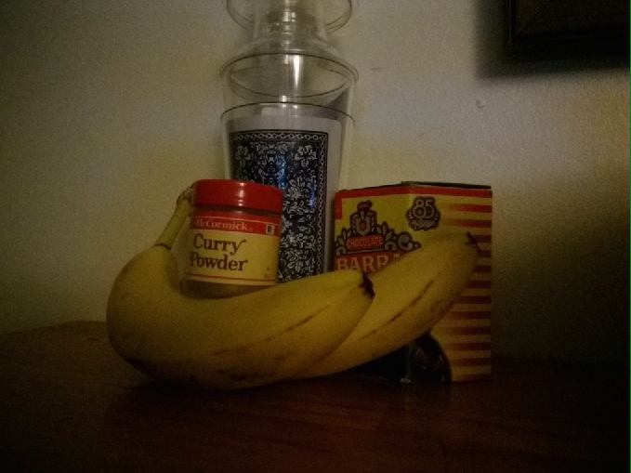

1. r 0.15 and s 1

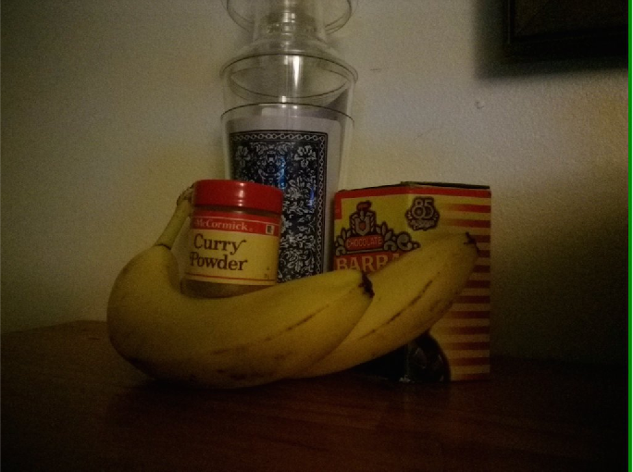

1. Comparison between r = 0.15,s =1 (on the left) and r = 0.25, s =64 (on the right)

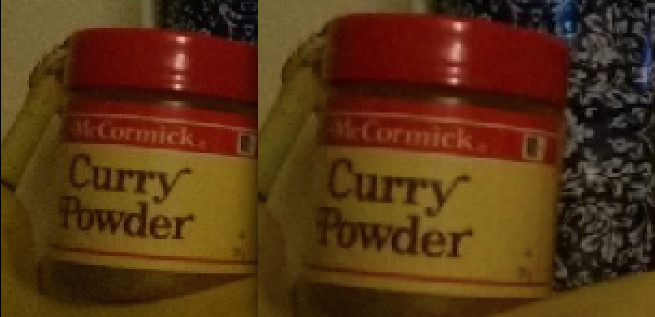

The picture on the right has a little less noise than the image on the left as evidenced by the lettering “Curry Powder.” Also when looking at the top of the banana stem, one can see harder edges on the left image and softer edges on the right.